**Supplemental content for: Power outages and cardiovascular and respiratory hospitalizations among US older adults**

**Supplemental Table 1**: Distribution of power outage exposure by potential confounders for main analysis of county-level 8+ hour power outage exposure and CVD and respiratory hospitalizations in US 2018 Fee-For-Service Medicare beneficiaries.

|  |  |  |
| --- | --- | --- |
| **Proportion of county-days with 8+ hour power outage affecting ≥1% of county customers by potential confounder quartiles** | | |
| **Wind speed** | | |
|  | Quartile 1 | 0.009 |
|  | Quartile 2 | 0.009 |
|  | Quartile 3 | 0.010 |
|  | Quartile 4 | 0.022 |
| **Precipitation** | | |
|  | Quartile 1 | 0.013 |
|  | Quartile 2 | 0.014 |
|  | Quartile 3 | 0.012 |
|  | Quartile 4 | 0.011 |
| **Daily maximum temperature** | | |
|  | Quartile 1 | 0.022 |
|  | Quartile 2 | 0.012 |
|  | Quartile 3 | 0.009 |
|  | Quartile 4 | 0.008 |

**Supplemental Table 2**: Rate ratios and 95% confidence intervals for the association between county-level 8+ hour power outage exposure and CVD and respiratory hospitalizations in US 2018 Fee-For-Service Medicare beneficiaries for outages affecting ≥1%, ≥3%, and ≥5% of county electrical customers. Estimates are from conditional Poisson regression models adjusted for daily wind speed, temperature, and precipitation.

CVD, cardiovascular disease; Resp, respiratory disease.

|  |  |  |  |  |  |  |  |  |
| --- | --- | --- | --- | --- | --- | --- | --- | --- |
| Power outage cut point | Outcome type | Lag day 0 | Lag day 1 | Lag day 2 | Lag day 3 | Lag day 4 | Lag day 5 | Lag day 6 |
| 1% | CVD | 1.002,  [0.99, 1.014] | 1.020,  [1.013, 1.026] | 1.023,  [1.014, 1.032] | 1.006,  [0.999, 1.012] | 0.988,  [0.98, 0.997] | 0.992,  [0.986, 0.998] | 1.009,  [0.997, 1.021] |
| 3% | CVD | 1.016,  [0.999, 1.032] | 1.027,  [1.018, 1.036] | 1.027,  [1.015, 1.039] | 1.009,  [1.001, 1.018] | 0.993,  [0.981, 1.005] | 0.995,  [0.987, 1.003] | 1.009,  [0.993, 1.025] |
| 5% | CVD | 1.025,  [1.005, 1.045] | 1.031,  [1.021, 1.042] | 1.029,  [1.014, 1.044] | 1.014,  [1.004, 1.024] | 1.000,  [0.986, 1.014] | 1.000,  [0.991, 1.01] | 1.010,  [0.991, 1.03] |
| 1% | Resp | 1.025,  [1.012, 1.038] | 1.017,  [1.01, 1.024] | 1.009,  [1.003, 1.016] | 1.004,  [0.995, 1.012] | 1.000,  [0.993, 1.007] | 0.998,  [0.992, 1.004] | 0.997,  [0.985, 1.01] |
| 3% | Resp | 1.052,  [1.034, 1.071] | 1.031,  [1.022, 1.04] | 1.013,  [1.004, 1.022] | 1.001,  [0.99, 1.012] | 0.997,  [0.988, 1.006] | 0.999,  [0.99, 1.007] | 1.004,  [0.987, 1.021] |
| 5% | Resp | 1.067,  [1.046, 1.089] | 1.039,  [1.029, 1.05] | 1.016,  [1.005, 1.027] | 1.001,  [0.988, 1.014] | 0.997,  [0.987, 1.008] | 1.001,  [0.991, 1.011] | 1.009,  [0.988, 1.029] |

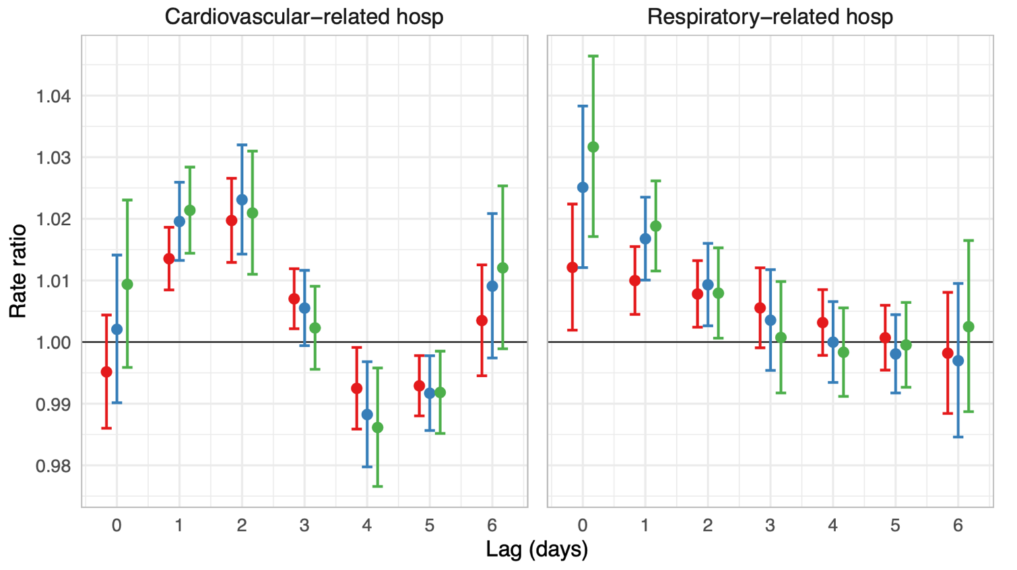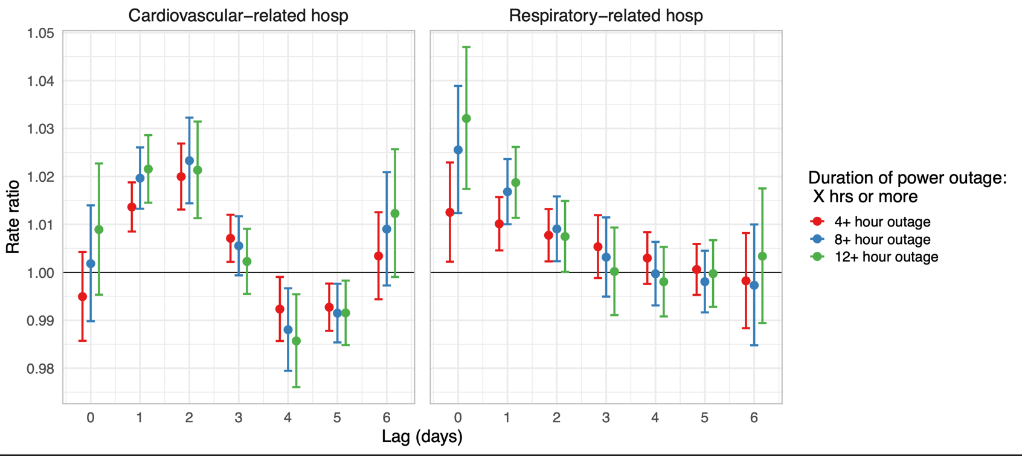

**Supplemental Figure 1**: Rate ratios and 95% confidence intervals for the association between county-level 8+ hour power outage exposure and CVD and respiratory hospitalizations in US 2018 Fee-For-Service Medicare beneficiaries for 4+, 8+, and 12+ hour power outages affecting ≥1% of county customers. Estimates are from conditional Poisson regression models adjusted for daily wind speed, temperature, and precipitation.

**Supplemental Figure 2**: Rate ratios and 95% confidence intervals for the association between county-level daily number of hours without power and cardiovascular- and respiratory-related hospitalizations in US 2018 Medicare Fee-For-Service beneficiaries. Estimates are from conditional Poisson regression models adjusted for daily wind speed, temperature, and precipitation. Results are from the best fitting model tested, with a linear relationship between number of hours without power and respiratory hospitalizations or CVD hospitalizations, and 4 degrees of freedom on the lag dimension.

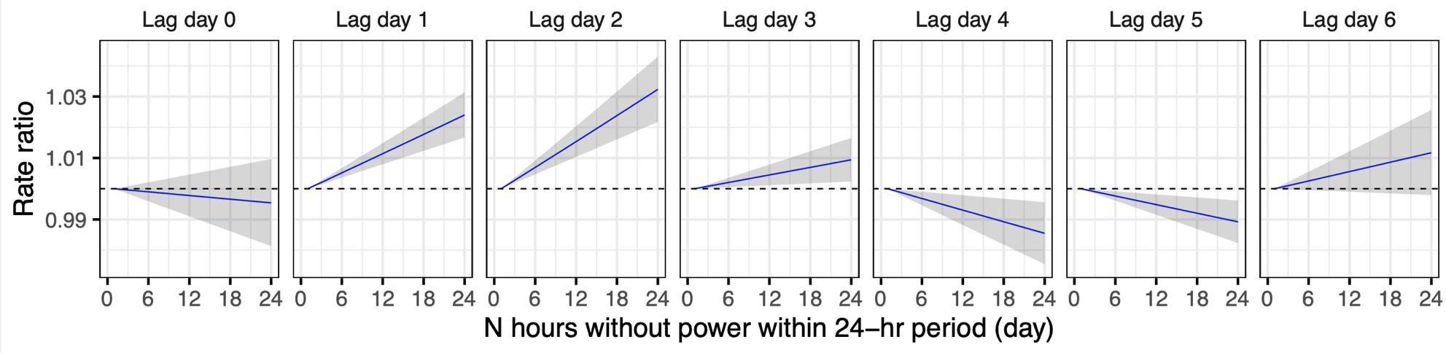Cardiovasular-related hospitalizations

Respiratory-related hospitalizations

